A Guide to understanding Psychosis
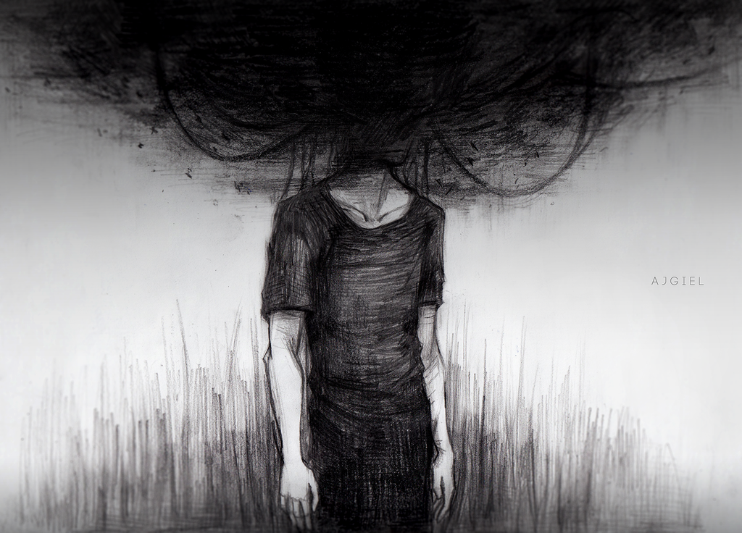

What’s inside:

- What is Psychosis and what does it look like?
- How is Psychosis treated?

- Some Helpful Links for further information regarding psychosis:

What is Psychosis and what does it look like?
Psychosis is a well-known condition that is frequently misunderstood. Often when people hear the term ‘Psychosis’ they immediately think of ‘split personalities’, ‘serial killers’ and other sensational pieces of information. In reality, the vast majority of individuals with psychosis do not have multiple personalities and do not kill people. The common overuse of words like ‘Psycho’ and ‘Psychotic’ has developed and promoted the misperception that psychosis is an overtly violent and dangerous condition that affects people from troubled homes or who have some brain kind of brain damage. In truth Psychosis can arise as a result of a number of reasons and can affect all kinds of people from all kinds of backgrounds.
Psychosis is often described as a “loss of reality” or a “break from reality” because it makes you experience or believe things that aren’t real. It can change the way you think, act, feel or sense things. Psychosis can be very scary and confusing, and it can significantly disrupt your life. In fact, the World Health Organization (WHO) ranks psychosis as the third-most disabling medical condition in the world.
Psychosis is a syndrome or group of symptoms. Psychosis itself isn’t a disease or disorder—it’s usually a sign that something else is wrong. People who are psychotic have false thoughts (delusions) and/or see or hear things that are not there (hallucinations). These are referred to as “positive” symptoms; “negative” symptoms like loss of motivation and social withdrawal can also occur.
Symptoms of Psychosis depend on the type of presentation and can be different from person to person. Some of these include:
- Changes in thinking patterns
People experiencing psychosis may have changes in their thinking patterns. For example, they may have difficulty when they try to concentrate, follow a conversation or remember things. Thoughts may become jumbled, or they may not connect in a way that makes sense.

- Unusual or false beliefs
People experiencing a psychotic episode often develop false beliefs called delusions. A person may be truly convinced of a belief that is not shared by others, and even the most logical argument cannot change his or her mind. Examples of such beliefs include believing that one is being followed by others, or being monitored by cameras, or believing one’s thoughts are being controlled by an outside force.

- Changes in perception
During psychosis, people may hear, see, smell, taste or feel something that is not actually there. For example, they may hear voices or noises that no one else hears, see things that are not there, or experience unusual physical sensations. These changes in perception are called hallucinations.

- Changes in feeling and mood
Mood swings are often experienced during a psychotic episode. A person may feel unusually excited, depressed or anxious. He or she may also feel very little emotion or show less emotion to others who are around.

- Changes in behaviour
People experiencing a psychotic episode may behave differently from how they usually do. Often the changes in behaviour are associated with the symptoms described above. People may laugh at inappropriate times or become upset for no apparent reason. They may spend more time alone or seem less interested in friends, school or work. The symptoms of the illness may also disrupt sleeping and eating patterns. For example, people may sleep less because they are preoccupied, or they may not eat for fear their food has been poisoned.
Some people experiencing a psychotic episode may feel very depressed, and think that life is not worth living. People experiencing suicidal thoughts may attempt to hurt themselves. Suicidal thoughts should always be discussed with a health professional/therapist. Family members may need support and assistance to cope effectively in such situations. In an urgent situation, the person should be taken to the emergency department of the closest hospital to receive treatment.
Research suggests that approximately 3% of the population will experience some form of psychosis in their lifetime. Psychosis occurs across all cultures and levels of socioeconomic status and affects males and females equally. Psychosis can occur as a result of an illness, medical condition, drug use and stress. Some conditions in which psychosis may be present include: schizophrenia, bipolar disorder, depression, brain injury/ brain, tumor, or a thyroid disorder.
Unfortunately, at this time there are many theories about what causes psychosis, but no definite answers. Because psychosis occurs in a variety of mental and physical disorders it likely has multiple causes. Biology, stress and drug use are widely supported as being contributors to the development of psychosis.
- Biology. There is strong evidence that psychosis involves a dysfunction in neurotransmitters, the “chemical messengers” in the brain, particularly dopamine. Those with a family history of psychosis seem to be at an increased risk of developing it themselves. For example, the risk of developing à psychosis associated with schizophrenia is approximately 1%. This risk increases to 13% if you have a parent with schizophrenia and 9% if you have a sibling. There is also some evidence that those who have experienced some types of psychosis have had changes in the brain. Possible causes of the changes include: genetics, abnormal neurodevelopment due to pregnancy or birth complications.

- Stress. Stress or stressful events, such as divorce, loss of a loved one, giving birth, or a traumatic event, can contribute to the development of psychosis. The amount of stress that may trigger psychosis differs for each person and likely contributes greater to those that are already vulnerable to developing psychosis.

- Drugs. Psychosis can be induced by drugs or can be drug assisted. For example, it appears that amphetamines can cause a psychotic episode, while other drugs, including marijuana, can increase a person's natural vulnerability to psychosis resulting in a psychotic episode.
There are many different kinds of psychosis, including organic psychosis, drug-induced psychosis, depressive psychosis, schizophreniform disorder, schizoaffective disorder, schizophrenia and bipolar disorder.
- Organic psychoses are characterized by abnormal brain function that is caused by a known physical abnormality, which in most cases is some organic disease of the brain.

- Drug-induced psychosis is a form of psychosis where illness can be attributed to substance use.
- Depressive psychosis is major depression with psychotic symptoms.

- Schizophreniform disorder is a mental disorder diagnosed when symptoms of schizophrenia are present for a significant portion of the time within a one-month period, but signs of disruption are not present for the full six months required for the diagnosis of schizophrenia.

- Schizoaffective disorder is a condition in which a person experiences a combination of schizophrenia symptoms — such as hallucinations or delusions — and mood disorder symptoms, such as mania or depression.

- Schizophrenia is psychosis that lasts longer than six months. Schizophrenia is a lifelong disease.

- Bi-polar disorder is a mental disorder marked by alternating periods of elation and depression.

How is Psychosis treated?
There are a number of options for the treatment of psychosis. Treatment for psychosis involves using a combination of antipsychotic medicines and psychological therapies. Treatment will vary depending on the underlying cause - for example, your treatment may be slightly different if you have been diagnosed with another health condition as well.

- Medication.
Antipsychotic medicines, also known as neuroleptics, are usually recommended as the first-line treatment for psychosis. Antipsychotics work by blocking the effect of dopamine (a chemical that transmits messages in the brain). There are two main types of antipsychotics:
  - typical antipsychotics - the first generation of antipsychotics that were developed during the 1950s

  - atypical antipsychotics - a newer generation of antipsychotics that were developed during the 1990s

Atypical antipsychotics are usually recommended as they have less potential to cause side effects. However, they are not suitable or effective for everyone as the side effects can affect people differently.
Antipsychotics can usually reduce feelings of anxiety or aggression within a few hours of use, but they may take several days or weeks to reduce other psychotic symptoms, such as hallucinations or delusional thoughts. Depending on the underlying cause of your psychosis, you may only need to take antipsychotics until your psychosis subsides. However, if you have a condition such as schizophrenia or bipolar disorder, you may need to take antipsychotics on a long-term basis in order to prevent further episodes of psychosis.

- Psychotherapy. Psychological treatment, such as counselling or psychotherapy (a talking therapy), can help to reduce the intensity and anxiety that is caused by psychosis. Some possible psychological treatments are discussed below.

  - Cognitive behavioural therapy (CBT) for psychosis is based on an understanding of how people make sense of their experiences and why some people become very distressed by them. The aim of CBT is to identify the unhelpful thinking patterns and emotions that may be causing your unwanted feelings and behaviours. It is then possible to learn to replace this thinking with more realistic and balanced thoughts. A CBT therapist may encourage you to consider different ways of understanding what is happening to you. The aim is to help you achieve goals that are meaningful and important to you, such as reducing your distress, returning to work or university, or regaining a sense of control.

  - Family therapy is known to be an effective treatment for people with schizophrenia in particular. It is also sometimes used to treat people who have experienced an episode of psychosis. Family therapy is a way of helping both you and your family to cope better with your condition. After experiencing an episode of psychosis, you may rely on your family members for their care and support. While most family members are happy to help, the stress of caring for somebody can place a strain on any family.

Some Helpful Links for further information regarding psychosis:

Early Psychosis Intervention. This website contains information the process of diagnosis and intervention of psychosis in Canada.

http://www.earlypsychosis.ca/

Here to Help. Source for further information regarding psychosis and substance abuse.

http://www.heretohelp.bc.ca/factsheet/psychosis#could%20i

Centre for Addiction and Mental Health. Further information on the treatment of psychosis.

http://www.camh.ca/en/hospital/health_information/a_z_mental_health_and_addiction_information/psychosis/first_episode_psychosis_information_guide/Pages/fep_treatment.aspx

Ms. Niamh Allen, M.A. B.Sc.

